Before creating template, we should inform express what template engine we are going to use, because express work with different template engine like handlebar, ejs, pug etc.

What is template engine in express:

template engine enables you to use static template files in your application. At runtime, the template engine replaces variables in a template file with actual values, and transforms the template into an HTML file sent to the client. This approach makes it easier to design an HTML page.

Steps to inform express that we are going to use what template engine.

Step 1:

Install template engine in application using below command, here we are going to use ejs template engine to create view.

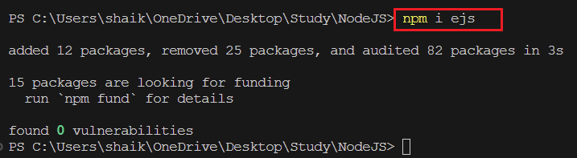

Step 2:

in app.js file we need to set ‘view engine’ with template engine (like ejs, handlebar, pug) and also inform express our views are stored in views folder to please pick views from views folder as shown below.

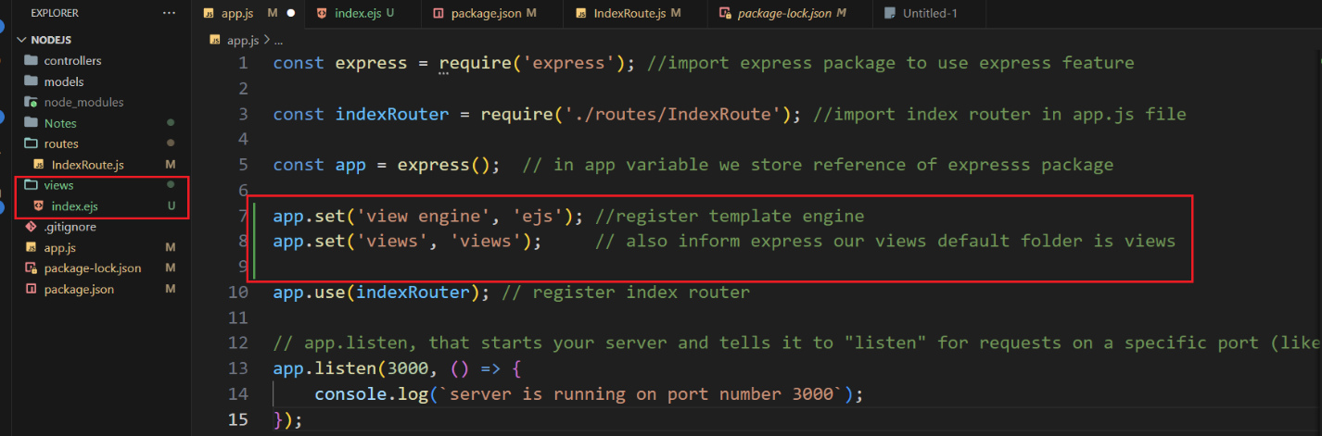

Step 3:

Now to see your created view from route we will create new route or modify existing route to tell express we are going to serve given template when specific route is requested. We will use **render** method to serve template as shown below screenshot.

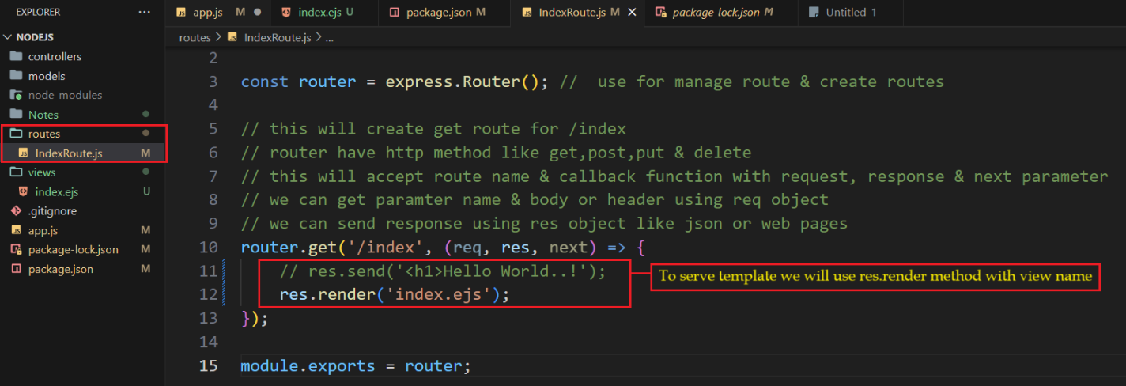

Now open browser and enter URL <http://localhost:3000/index> and we will see our first ejs template in browser.

